COMSATS UNIVERSITY ISLAMABAD
ATTOCK CAMPUS


SOFTWARE QUALITY ENGINEERING
LAB ASSIGNMENT NO 04 + LAB TERMINAL
Submitted To: | 18TH May 2026
Name | Eman Fatima
Reg No | FA23-BSE-017

LAB TERMINAL:
Project Title: STUDENT MANAGEMENT SYSTEM IN PYTHON
1. Functionalities (Core Features)
Your system should include at least 5 functionalities:
- Add Student
- View Students
- Search Student
- Update Student
- Delete Student
Phase 1: System Development
PYTHON CODE:
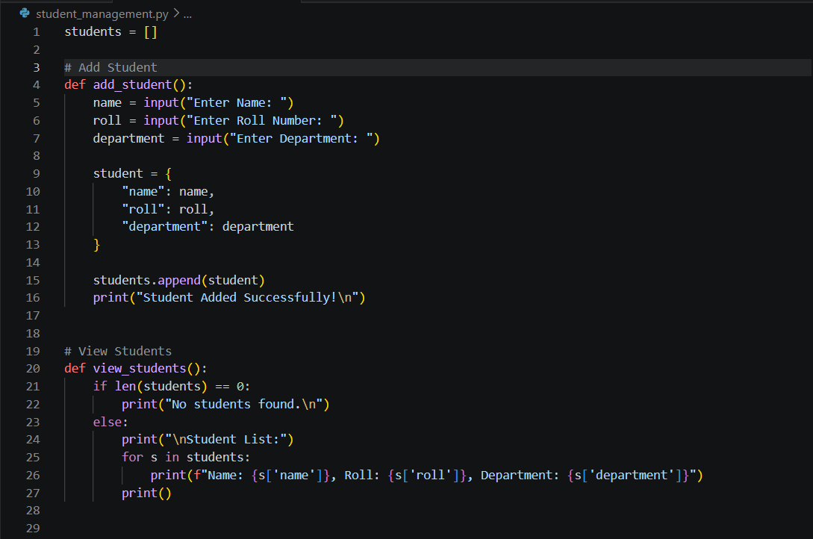

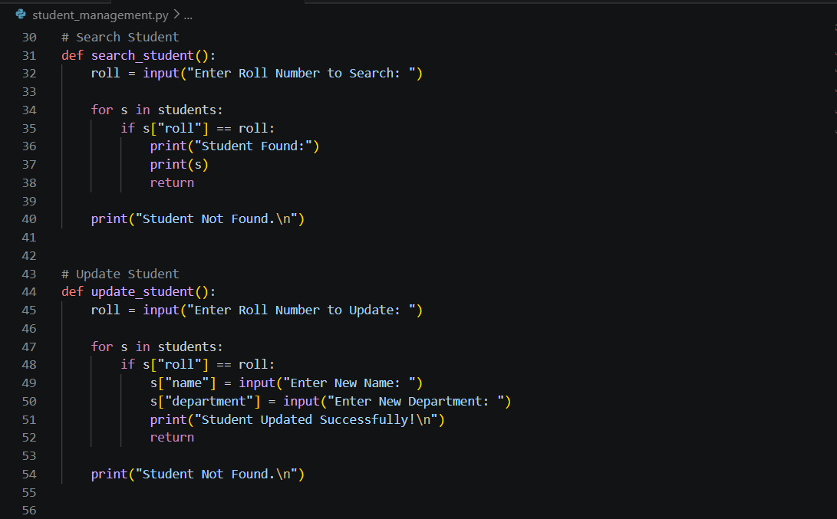
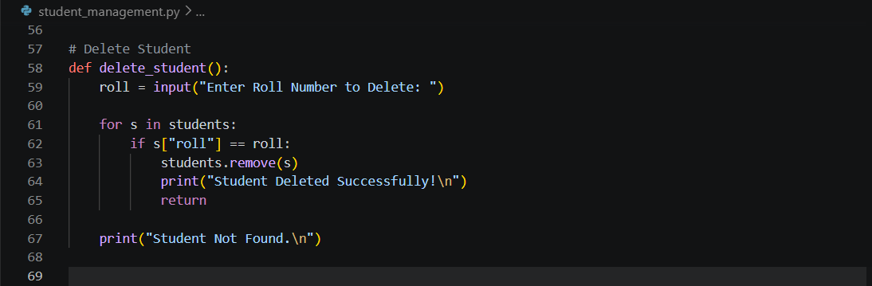
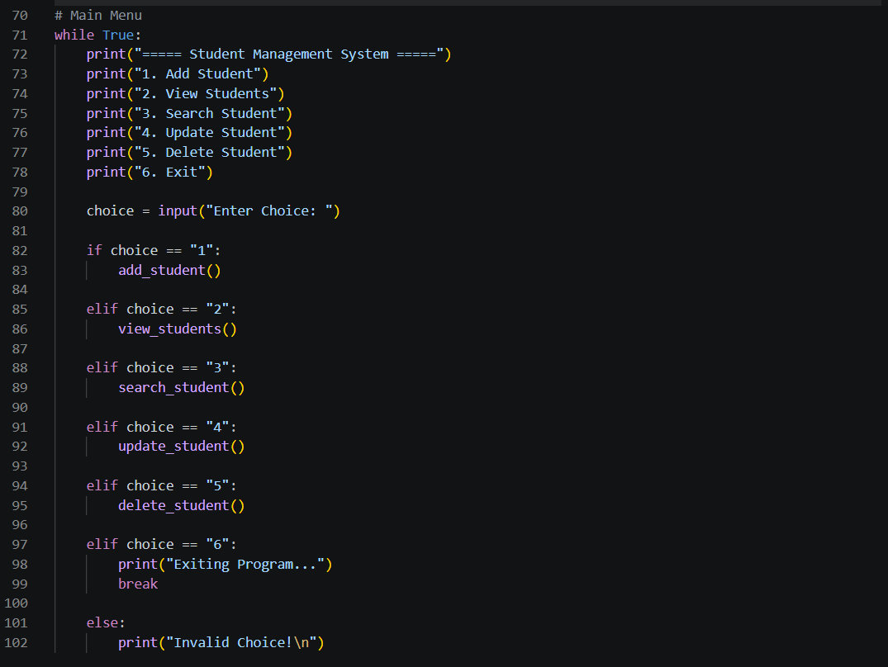
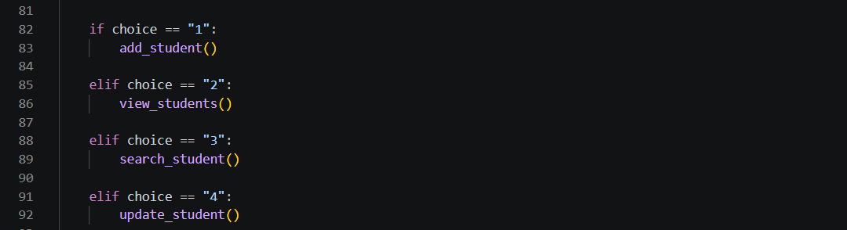
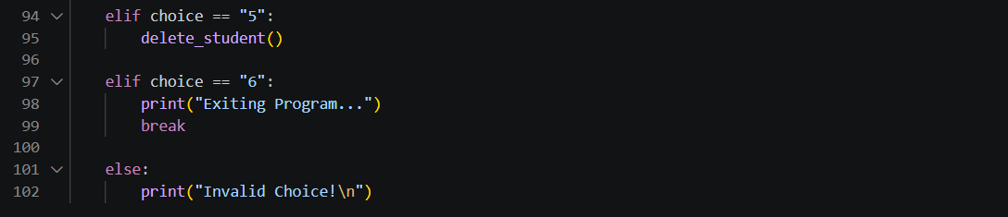
3. Manual Test Cases
Test Case ID | Function | Input | Expected Output | Actual Output | Status
TC01 | Add Student | Eman, 017, CS | Student added successfully | Student added successfully | Pass
TC02 | View Students | Click View Students | Display all students list | Students displayed correctly | Pass
TC03 | Search Student | Roll No = 017 | Student Found | Student Found | Pass
TC04 | Search Student | Roll No = 999 | Student Not Found | Student Not Found | Pass
TC05 | Update Student | Roll No = 017 | Student information updated | Student updated successfully | Pass
TC06 | Delete Student | Roll No = 017 | Student deleted | Student deleted successfully | Pass
TC07 | Delete Student | Roll No = 999 | Student Not Found | Student Not Found | Pass

SCREENSHOTS:
Manual Test for ADD STUDENT:
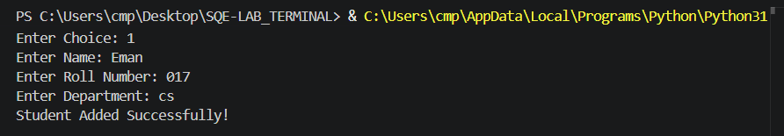
Manual Test for VIEW STUDENT:
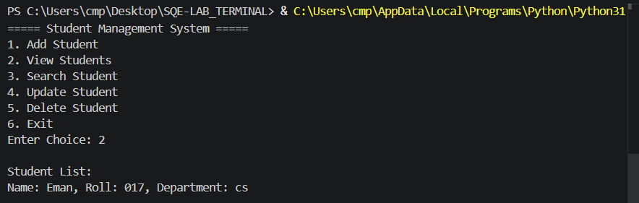
Manual Test for SEARCH STUDENT:
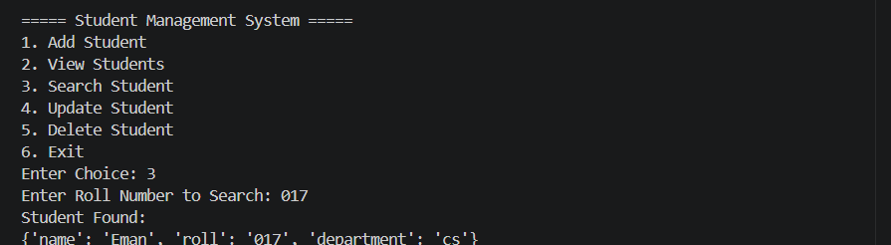
Manual Test for UPDATE STUDENT:
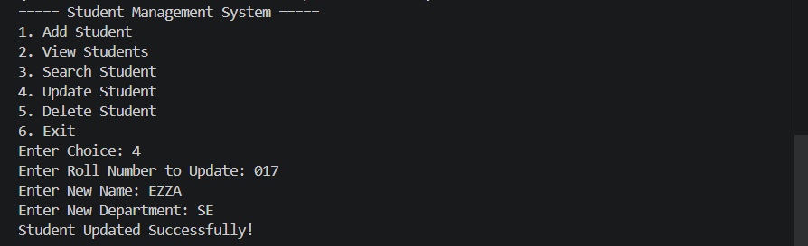
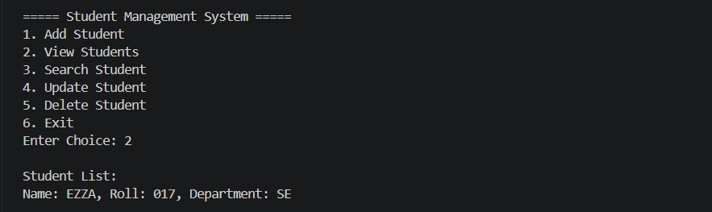
Manual Test for DELETE STUDENT:
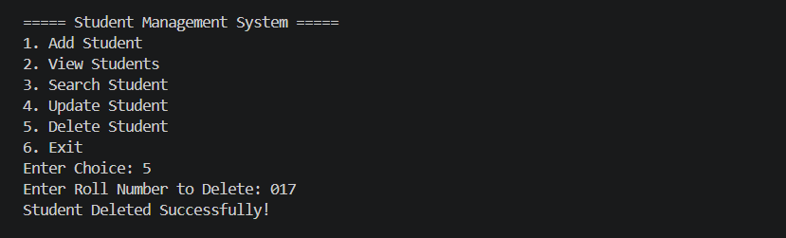
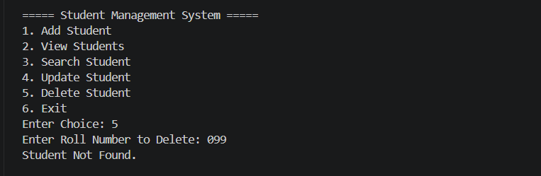
4. unittest Testing
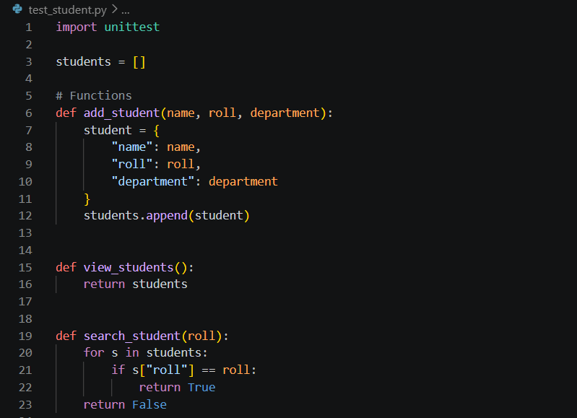
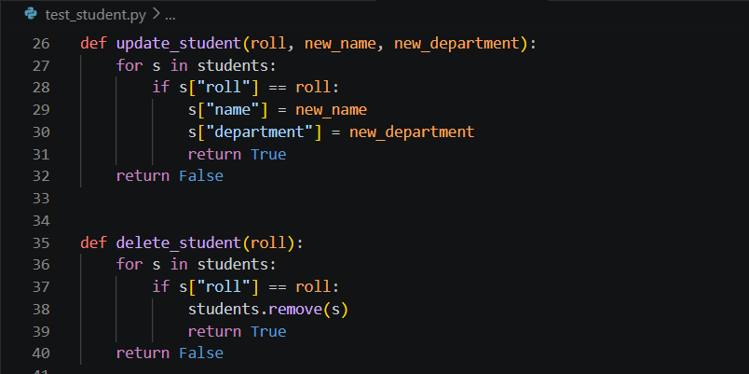
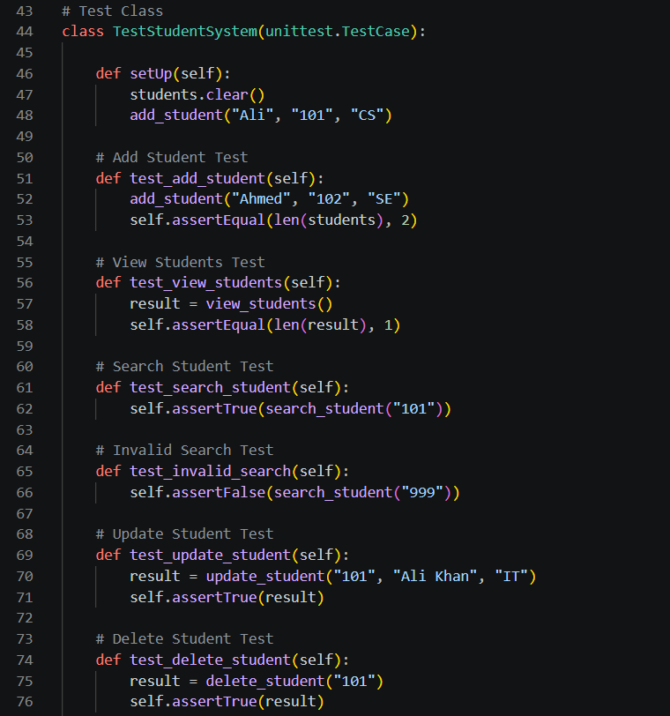
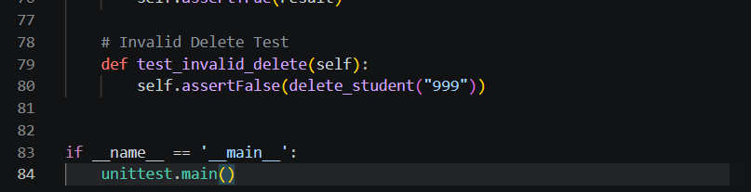
Output:
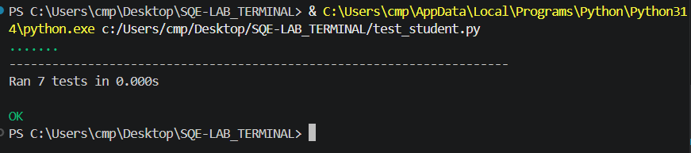
- BUG REPORT
5. Bug Report
Bug 1
Bug ID: BUG01
Bug Name: Empty Name Accepted
Description: System accepts student records even when the name field is empty.
Steps to Reproduce:
- Run the program
- Select Add Student
- Leave name field empty
- Enter roll number and department
- Save student
Expected Result:
System should display an error message and reject empty name input.
Actual Result:
Student is added successfully with an empty name.
Severity: Medium
Status (Pass/Fail): Fail
Bug 2
Bug ID: BUG02
Bug Name: Duplicate Roll Number Allowed
Description: System allows multiple students with the same roll number.
Steps to Reproduce:
- Add a student with roll number 101
- Add another student with the same roll number 101
Expected Result:
System should prevent duplicate roll numbers.
Actual Result:
Both student records are added successfully.
Severity: High
Status (Pass/Fail): Fail
Bug 3
Bug ID: BUG03
Bug Name: Invalid Menu Choice Handling
Description: System does not properly handle invalid menu inputs.
Steps to Reproduce:
- Run the program
- Enter an invalid menu option like 9 or abc
Expected Result:
System should show “Invalid Choice” message and continue safely.
Actual Result:
Unexpected behavior may occur.
Severity: Medium
Status (Pass/Fail): Fail

Bug 4
Bug ID: BUG04
Bug Name: Empty Roll Number in Search
Description: Search functionality accepts empty roll number input.
Steps to Reproduce:
- Run the program
- Select Search Student
- Leave roll number empty
Expected Result:
System should reject empty roll number input.
Actual Result:
System processes empty input without validation.
Severity: Low
Status (Pass/Fail): Fail
Bug 5
Bug ID: BUG05
Bug Name: Deleted Student Still Searchable
Description: Deleted student record may still appear during search in some cases.
Steps to Reproduce:
- Add a student
- Delete the student
- Search the same roll number
Expected Result:
Deleted student should not be found.
Actual Result:
Student may still appear in search results.
Severity: High
Status (Pass/Fail): Fail

- SonarQube Code Quality Analysis
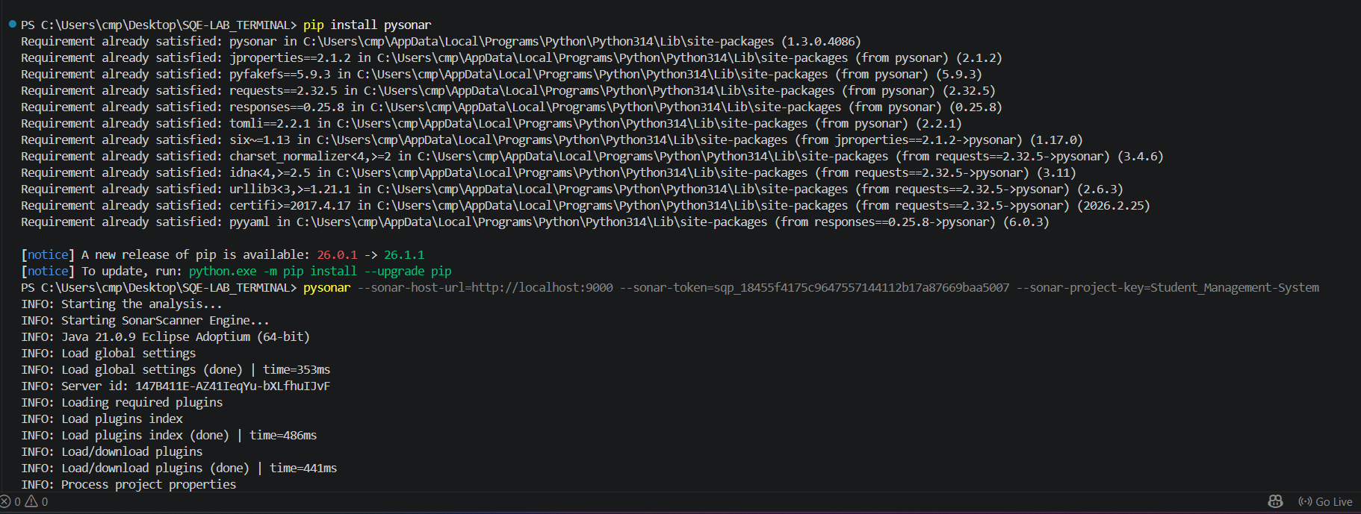
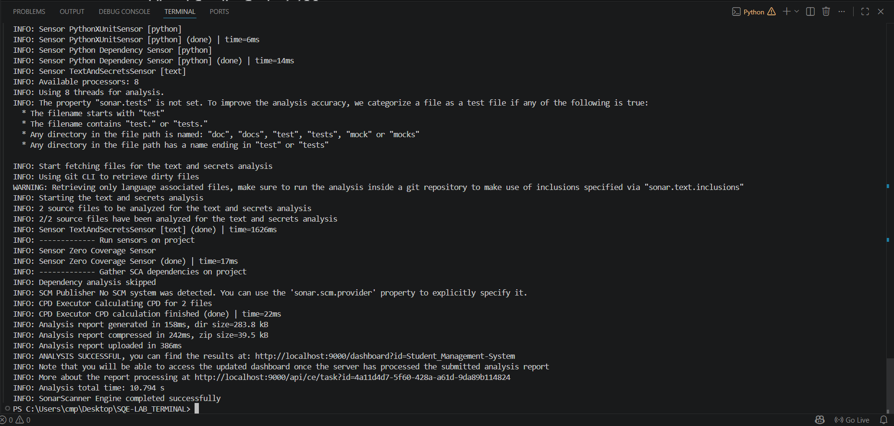
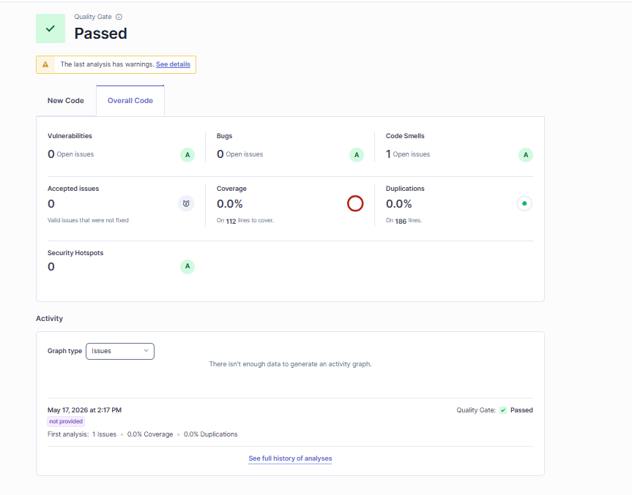
Phase 5: Security Analysis
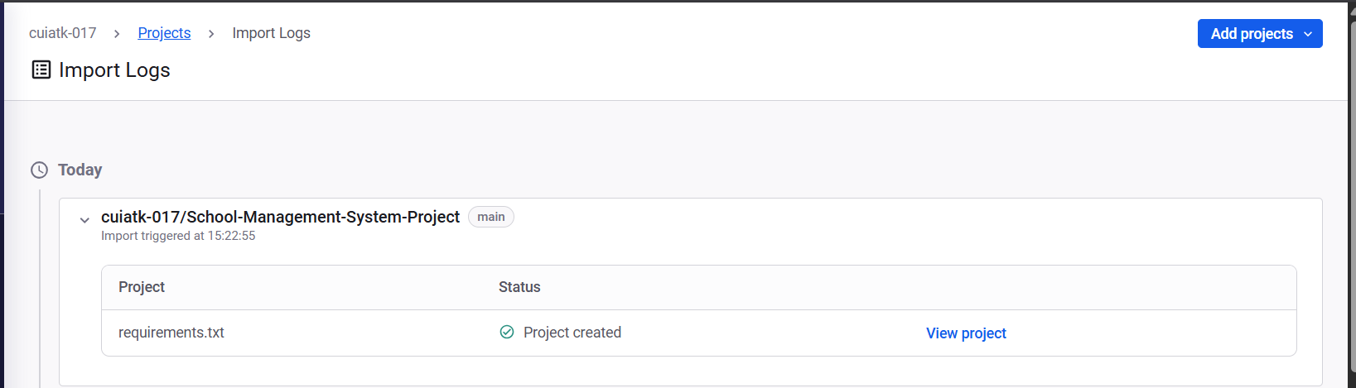
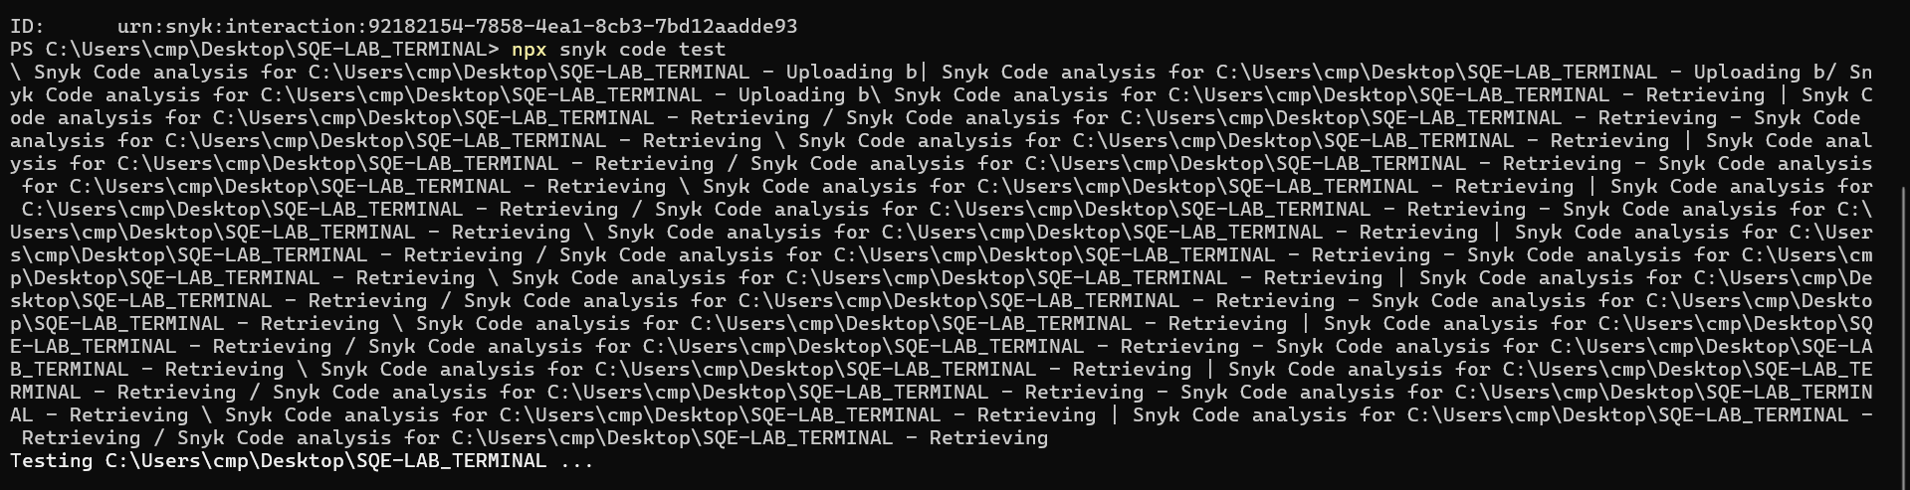
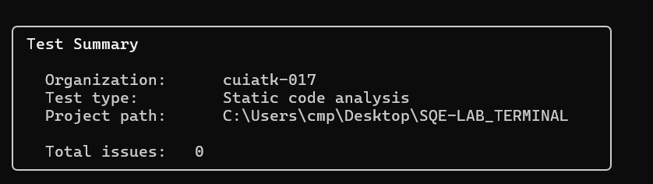
SUGGESTED FIXES:
Issue # | Problem | Why it’s a problem | Suggested Fix
1 | Mixed CLI + unittest in same file | Causes confusion and testing conflicts | Separate into app.py (CLI) and test_app.py (tests)
2 | Global variable students = [] | Shared state causes bugs and weak design | Pass students as a parameter to functions
3 | Duplicate logic (same functions twice) | Hard to maintain and error-prone | Keep one version in logic.py and reuse it
4 | search_student() returns True/False | Doesn’t return actual student data | Return student object or None
5 | Deleting while looping (students.remove(s)) | Can cause unsafe behavior in larger systems | Use indexed deletion (del students[i])
6 | No input validation | Allows empty or invalid data | Add checks for empty name/roll/department
7 | No duplicate roll check | Same roll number can be added multiple times | Check existing rolls before adding
8 | CLI functions tightly coupled with input() | Not reusable for testing or APIs | Separate logic from input/output
9 | No error handling | Program may crash on invalid input | Add basic try/except blocks
10 | No structured architecture | Hard to scale project | Use layered structure: UI + Logic + Tests

